1. Jira & Azure Dashboards
- What it is: Enterprise issue-tracking and project management databases.
- How it works:
  - Stores tasks as distinct database records called "issues."
  - Attaches metadata to tasks like assignees, priorities, and status.
  - Visualizes database states using Scrum or Kanban boards.
  - Calculates team velocity using historical ticket completion rates.
2. Git & GitHub
- What it is: A distributed version control system (Git) paired with a cloud-based hosting platform (GitHub).
- How it works:
  - Git tracks code changes line-by-line using cryptographic snapshots.
  - Stores file history locally in a directed acyclic graph (DAG).
  - GitHub hosts these local repositories in a central cloud network.
  - Provides collaboration mechanisms like Pull Requests for peer reviews.
3. Maven & Gradle
- What it is: Build automation engines and dependency managers for software code.
- How it works:
  - Reads configuration files (pom.xml or build.gradle) to map project structures.
  - Downloads external third-party code libraries automatically from public registries.
  - Compiles raw human-readable source code into binary machine bytecode.
  - Packages compiled files into executable formats like .jar or .war files.
4. JUnit & Selenium
- What it is: Automated software testing frameworks.
- How it works:
  - JUnit executes isolated code logic blocks using code annotations.
  - Compares actual functional code outputs against expected values using assertions.
  - Selenium utilizes a specialized WebDriver API to communicate with browsers.
  - Sends native commands to Chrome or Firefox to simulate clicks and inputs.

5. Jenkins & GitHub Actions
- What it is: Continuous Integration and Continuous Delivery (CI/CD) automation servers.
- How it works:
  - Listens for code updates via webhooks sent from GitHub.
  - Spins up isolated execution environments called "runners" or "agents."
  - Executes automated operational scripts defined in YAML or Groovy code.
  - Orchestrates sequential steps: pull code, compile, test, and ship.

6. Docker & Kubernetes
- What it is: A containerization platform (Docker) and a container orchestration cluster manager (Kubernetes).
- How it works:
  - Docker uses Linux kernel features to isolate application processes.
  - Bundles code, runtimes, and dependencies into an immutable "image."
  - Kubernetes manages fleets of running Docker images across server groups.
  - Handles network routing, scales container instances, and replaces crashed instances.
7. Ansible
- What it is: An agentless configuration management and automation engine.
- How it works:
  - Connects to hundreds of remote servers concurrently over standard SSH protocols.
  - Requires no background software agent installed on the target machine.
  - Parses human-readable YAML configuration files called "Playbooks."
  - Executes localized Python modules to enforce identical server states.
8. Grafana
- What it is: A multi-platform data visualization and observability dashboard.
- How it works:
  - Connects to time-series databases that collect server performance data.
  - Queries raw metrics using specific query languages like PromQL.
  - Transforms raw text data into live, real-time charts and graphs.
  - Evaluates metrics against thresholds to send automated alerts when systems fail.

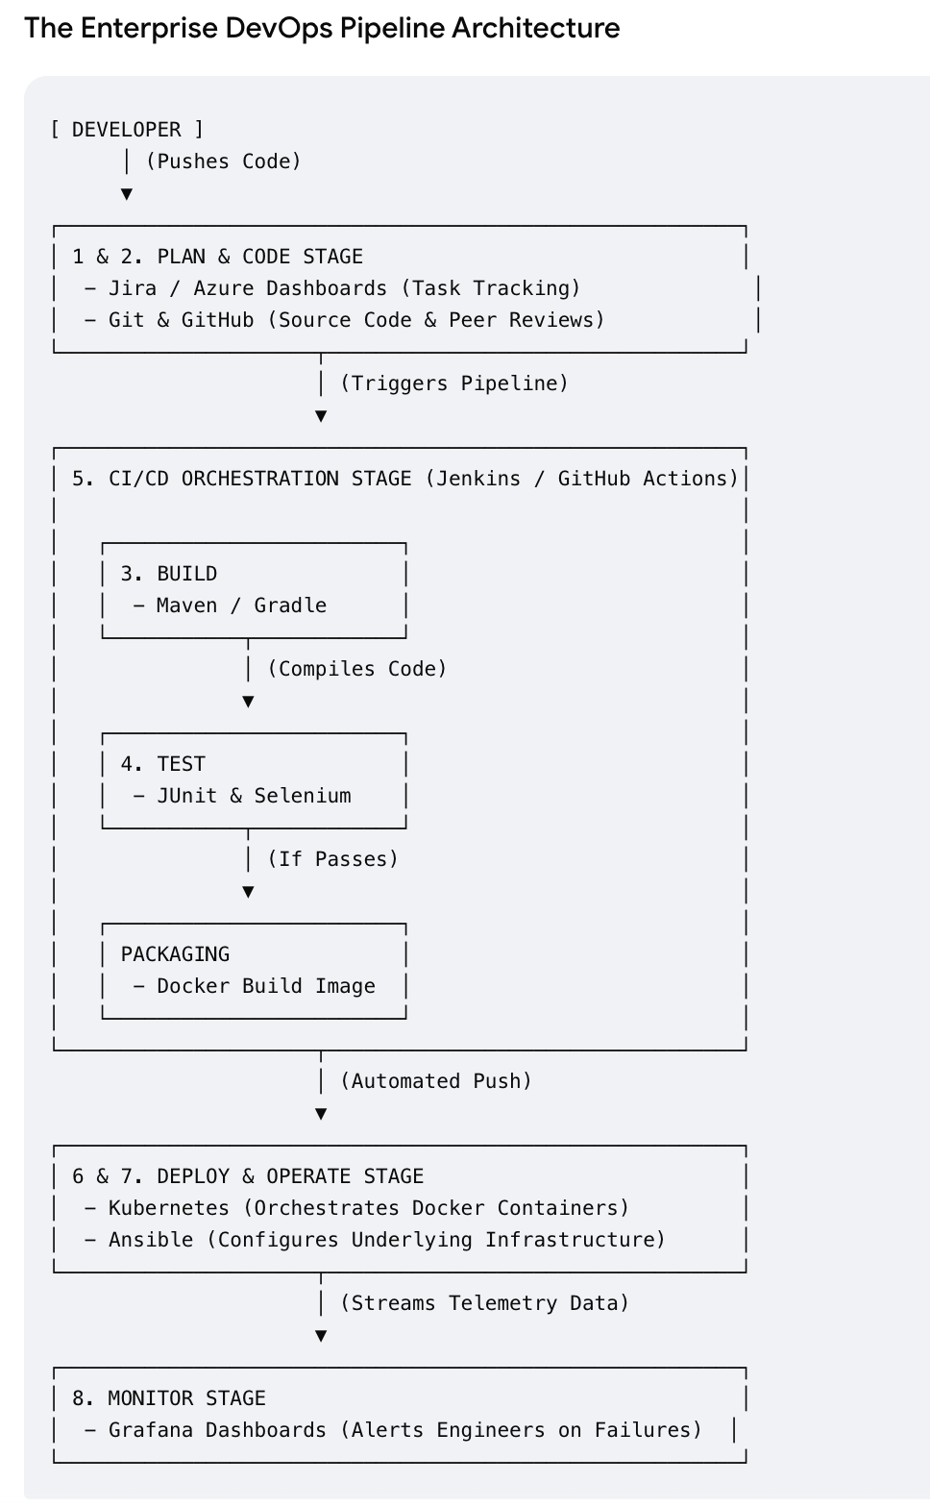

powerful, let's track the data flow step-by-step through a professional production environment: Step Tool Interaction Concrete Tech Action
- Triggers Jira Git/GitHub A developer picks up an issue marked In Progress on the Jira board and writes the fix in a local Git feature branch. They push the code to GitHub, where it is reviewed and merged into the main line.
- CI Run GitHub Jenkins Maven The code merge automatically alerts Jenkins. Jenkins pulls the fresh code and spins up Maven, which downloads external libraries and compiles the application into a raw software artifact.
- Test QA Jenkins JUnit / Selenium Jenkins instantly triggers JUnit to run internal code logic tests. Next, it boots up Selenium to launch headless browsers, executing user journeys (like logging in or purchasing) to guarantee no UI components broke.
- Ship Jenkins Docker Kubernetes If tests pass, Jenkins runs a docker build command, locking the fresh software inside an unchangeable Docker image. This image is pushed to a cloud registry. Kubernetes pulls the image and replaces old application instances with zero user downtime.
- Watch Ansible + Grafana Jira Ansible keeps the target cloud servers secured and configured. As live traffic hits the app, metrics feed directly into Grafana. If Grafana spots an anomaly, it fires an alert that opens a bug ticket back in Jira, closing the infinite DevOps loop.

